How To Gather Row Counts for Client’s table who are on Dynamics 365

1. Go to [https://*clientID*.crm.dynamics.com](https://clientID.crm.dynamics.com)
2. Go to Setup and select Customizations
   1. 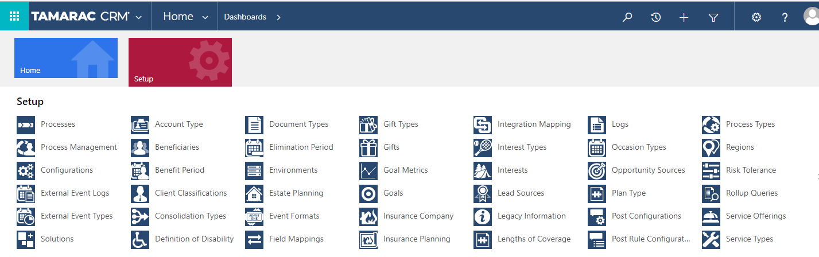
   2. 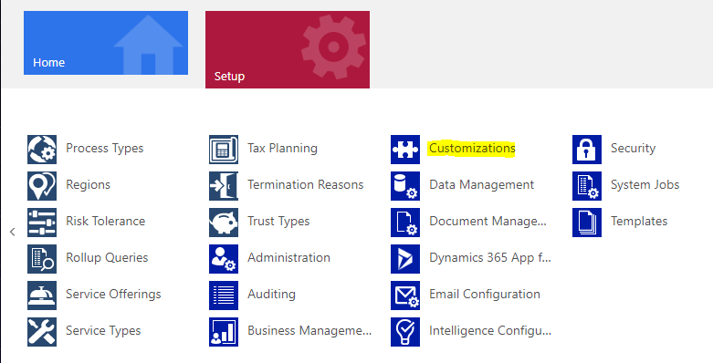
3. Select **Customize the System**
   1. 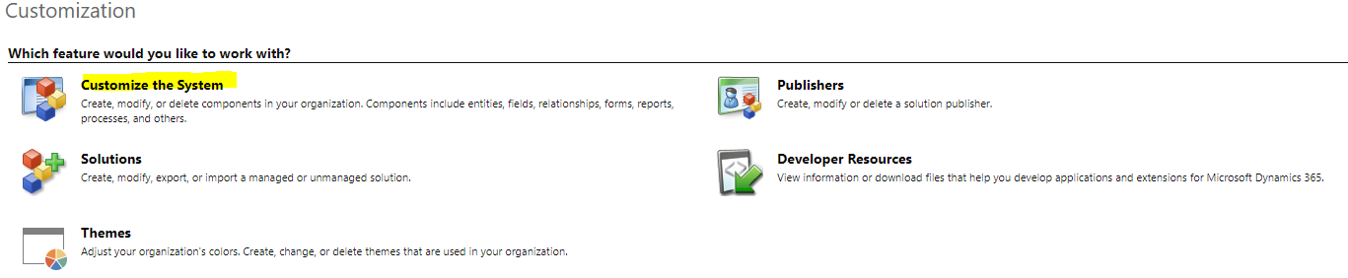
4. Select **Web Resources**
   1. 
5. Click on New
   1. 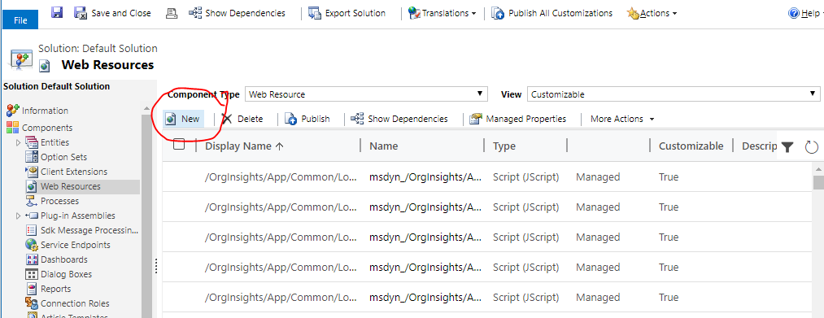
6. Make sure to fill out the highlighted fields identically and press save. The file to be uploaded can be found in this folder: \\CORP-FS2\Common\Product Support\CRM\CRM Implementation Team\Data Migration Analyst Reference Materials\365 row count query
   1. 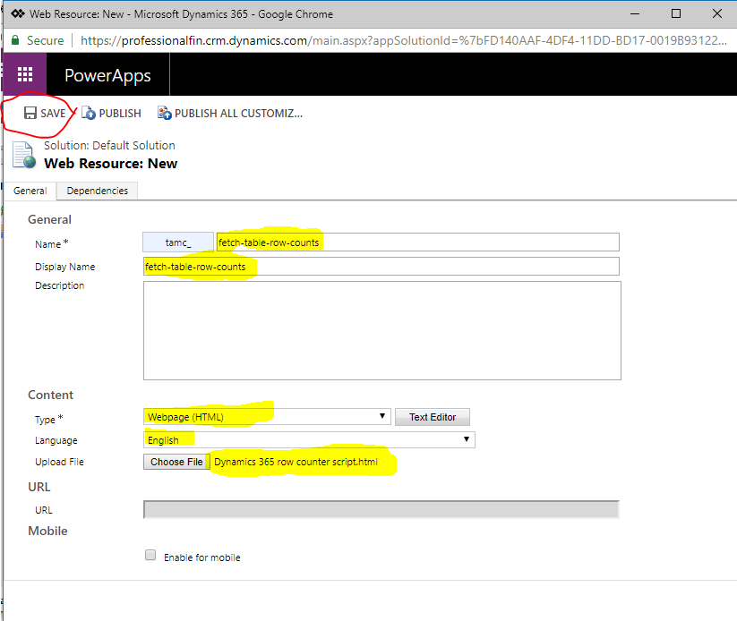
7. Click on the highlighted URL which will open a new window (Make sure to have pop-ups enabled!)
   1. 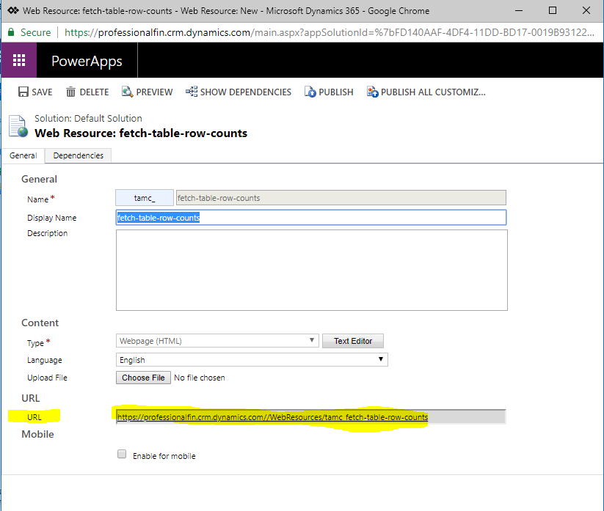
8. Follow the 3 steps on the pop up.
   1. 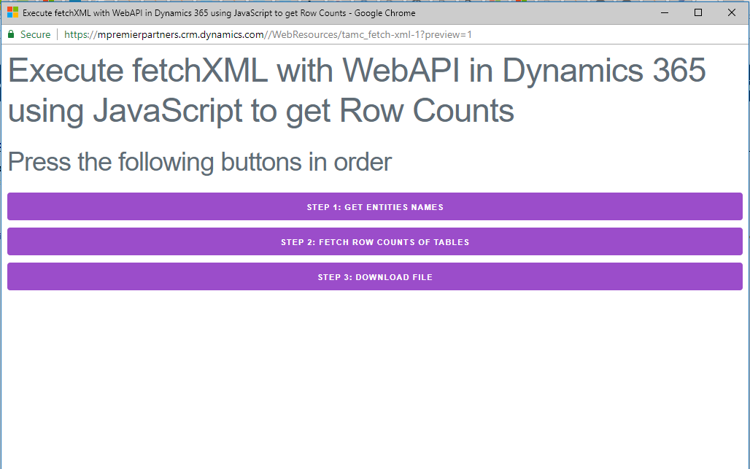
9. Then Delete the fetch-xml solution
10. Go to MySQL server crmstaging2016 and use the DatabaseRowCounts
11. Right click on the DatabaseRowCounts in the object Explorer and select Tasks> Import Flat Files.
12. On the wizard press next
    1. 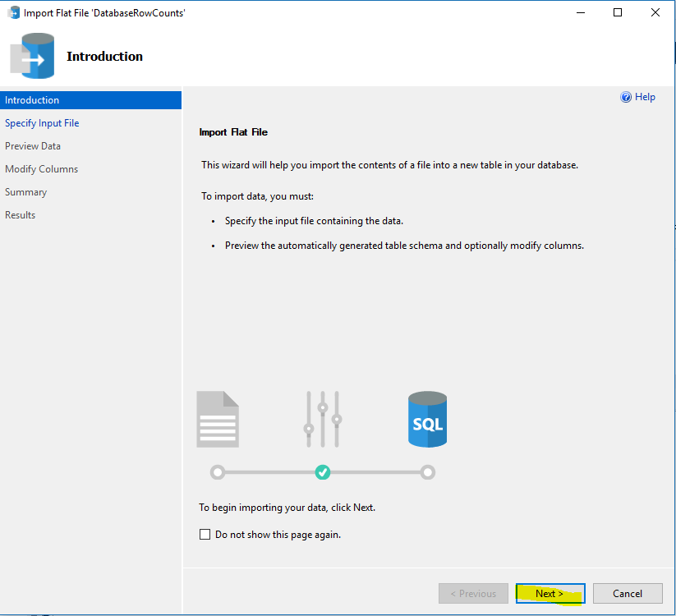
13. Click browse and select the csv file that was just selected. Make sure the table name is the same as the enterpiseID
    1. EXAMPLE: 0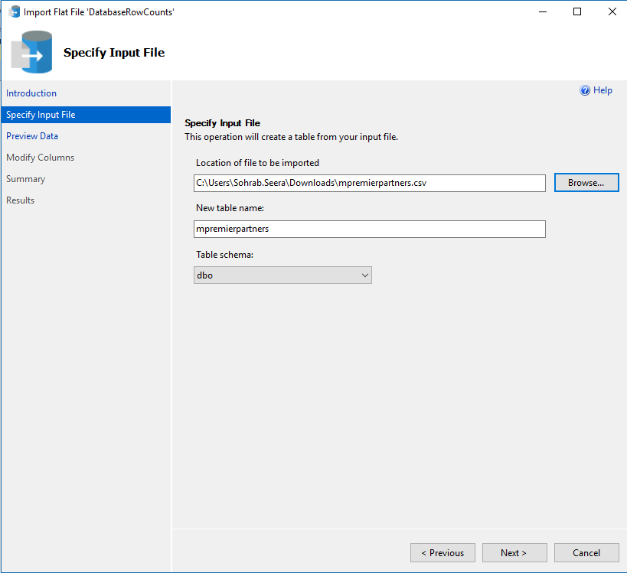
14. Then press keep pressing next till the finish button and press that without chaninging anything. If succesfull a green checkmark will show at the end as shown in pictures below
    1. 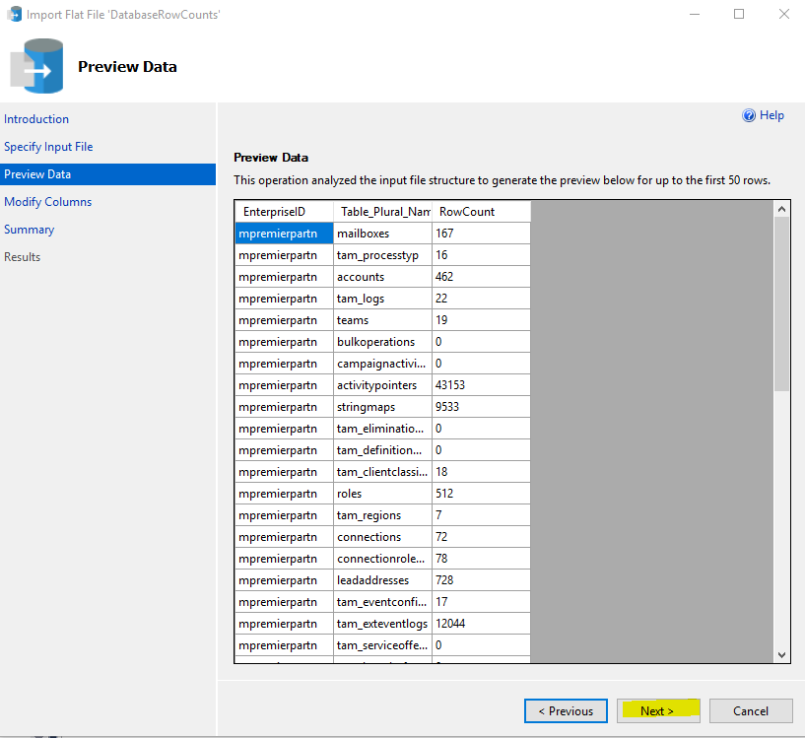
    2. 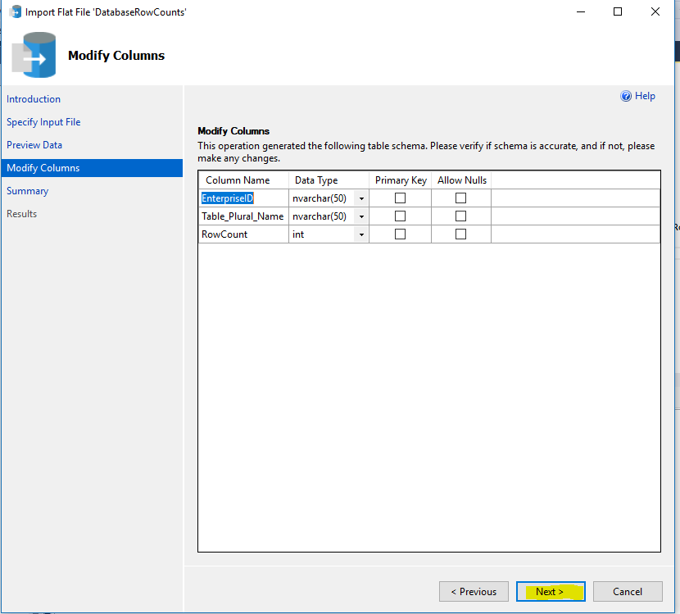
    3. 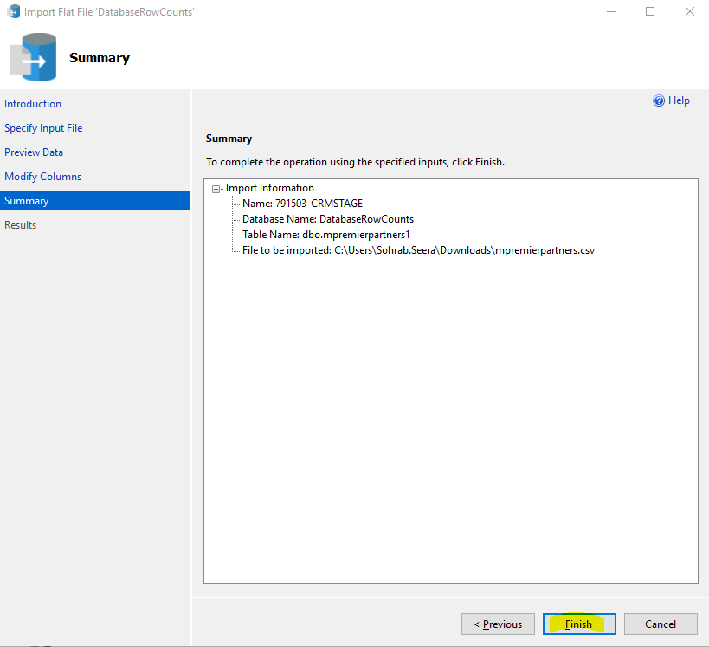
    4. 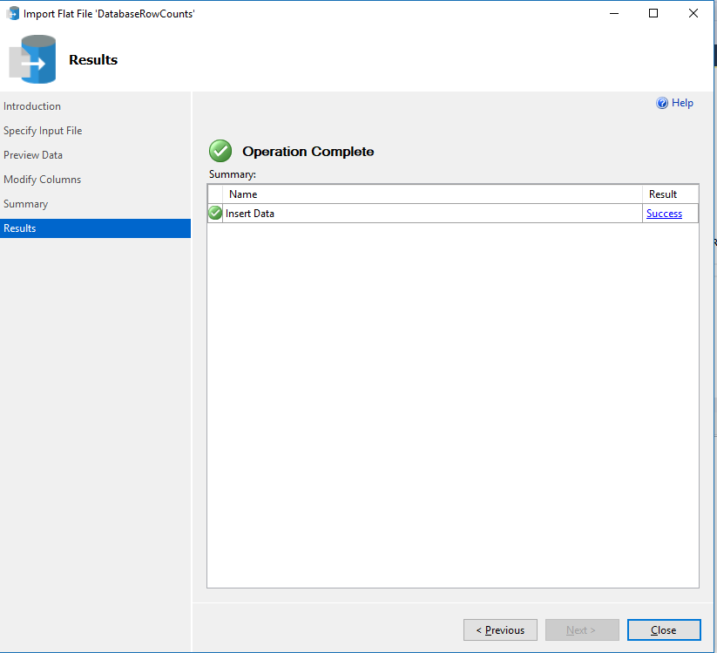
15. Then run the following code replacing ***clientID*** with the table’s name (which is also the enterpriseID) that was just imported.

USE DatabaseRowCounts

INSERT INTO RowCounts (EnterpriseID, Table_Plural_Name, [RowCount])

SELECT EnterpriseID, Table_Plural_Name, [RowCount]

from ***clientID*** as NewClient

WHERE

NOT Exists (Select * from RowCounts as RC Where RC.EnterpriseID = NewClient.EnterpriseID

AND RC.Table_Plural_Name = NewClient.Table_Plural_Name AND RC.[RowCount] = NewClient.[RowCount])

* 1. An example:
  2. 